
Specialist Maths Integrals Test 2015 Name: ____Solutions___________

The following criteria are being assessed:
Outcome 1 Define and explain key terms and concepts and apply a range of related mathematical routines.

- Criterion 1 Appropriate use of mathematical conventions, symbols and terminology.
- Criterion 2 Definition and explanation of key concepts.
- Criterion 3 Accurate use of mathematical skills and techniques.

Outcome 2 Apply mathematical processes in contexts related to the “Applications” area of study, and analyse and discuss these applications of mathematics.

- Criterion 1 Identification of important information, variables and constraints.
- Criterion 2 Application of mathematical ideas and content from the specified areas of study.
- Criterion 3 Analysis and interpretaion of results

Outcome 3 Select and appropriately use technology to develop mathematical ideas, produce results and carry out analysis in situations requiring problem solving, modelling or investigative techniques or approaches.

- Criterion 1 Appropriate selection and effective use of technology
- Criterion 2 Application of technology

Time allowed: 75 minutes

You may use 1 bound Reference book and CAS calculator.

Where a question is worth more than 1 mark full working must be shown.

Total Available = 45 marks

Section A: Multiple Choice. Choose the best answer for these questions and write legibly in the box shown:

1 | 2 | 3 | 4 | 5 | 6 | 7 | 8 | 9 | 10
B | D | C | E | D | C | E | B | D | A
10 marks

 | If a curve passes through the point  (2, −3) and at any point has a gradient given by 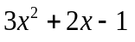, then the  y-intercept of the curve must be:  A −17  B −13  C −9  D −5  E −1 | b
 | The indefinite integral  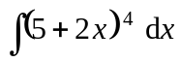 is equal to:  A 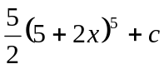  B 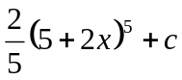  C 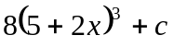  D 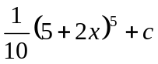  E 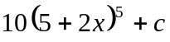 | D
 | 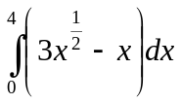equals:  - 2  - 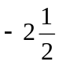  - 8  - 20  - 16 | c
 | The velocity of a car is given by 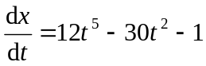. The position,  x metres, after the first 2 seconds is:  - 26 m  - 56 m  - 40 m  - 36 m  - 46 m | e
 | If 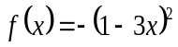 and 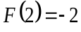, then  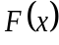 must equal:  A 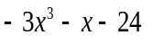  B 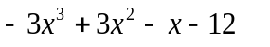  C 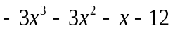  D 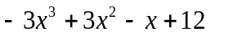  E 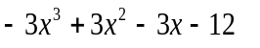 | d
 | If 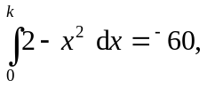then k equals:  A 2  B 4  C 6  D 8  E 10 | C
 | 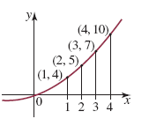  An approximation for the area between the curve and the x-axis over the interval [1, 4] in the diagram above using the average of the left and right rectangles is:  - 26 square units  - 16 square units  - 22 square units  - 17 square units  - 19 square units | e
 | A particle moves in a straight line so that its position x cm from a fixed point O at time t seconds (t ≥ 0) is given by x = t ³ − 12t ² + 24t − 5. The particle’s initial velocity is:  A 0 cm/s  B 24 cm/s  C 1 cm/s  D −1 cm/s  E 9 cm/s | B
 | The area between the graph of 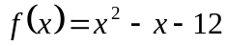 and the x-axis is:  A 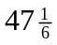 square units  B 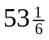 square units  C 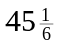 square units  D 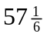 square units  E 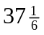 square units | D
 | The area between the curve 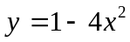 and the x-axis from x = 0 to x = 1 is:  A square units  B  square units  C 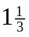 square units  D 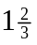 square units  E 1 square unit | A

Section B Complete working must be shown for all questions to gain full marks.

- Find an approximation for the area under the graph 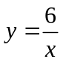 and the x-axis over the interval x = 1 to x = 5 using left rectangles and interval widths of 1 unit. (Hint: sketch a graph first)

left rectangles = 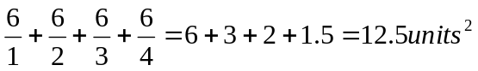

3 marks

- Evaluate these integrals, showing all working:
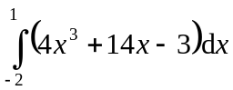  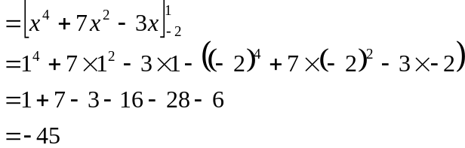 | 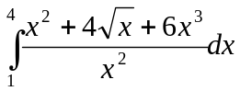  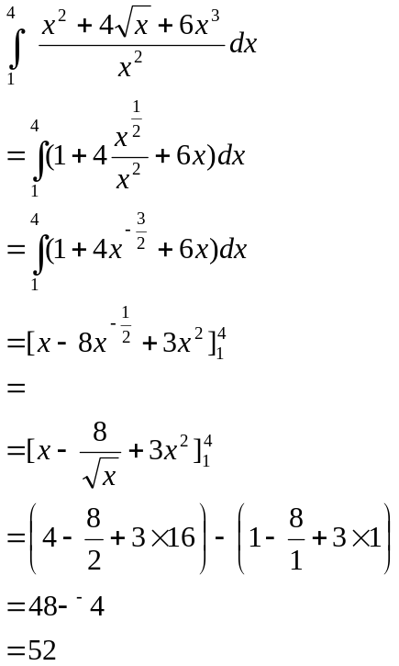
3 + 4 = 7 marks
- The amount of radioactive substance, A, in a stockpile is given by 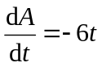, where t is measured in years and A in kilograms. Calculate the loss of material after 10 years if initially there is 2000 kg.

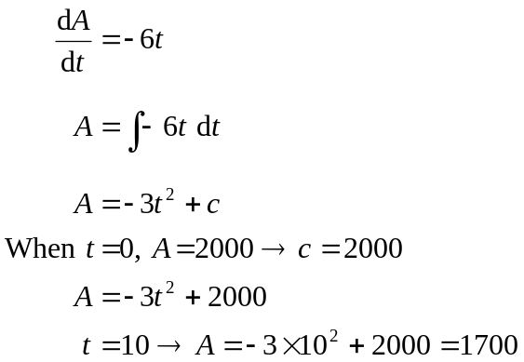 There just 1700kg left so the loss of material after 10 years is 300 kg.

4 marks
- The velocity, v m/s, of a moving body is given by 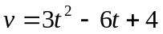. If the body’s initial displacement from O is 8 m,

  - What is the rule for its displacement, x m, at any time t seconds?

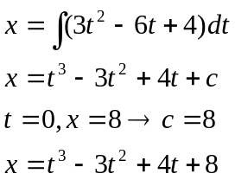

  - What is the velocity of the body after 2 seconds?

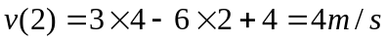

  - When is the acceleration of the body, a m/s², equal to zero?

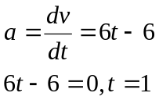

3 + 1 +2 = 6 marks

- Calculate the area between the curve 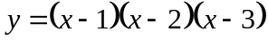and the x-axis from x = 0 to x = 3.Leave your answer as a fraction.
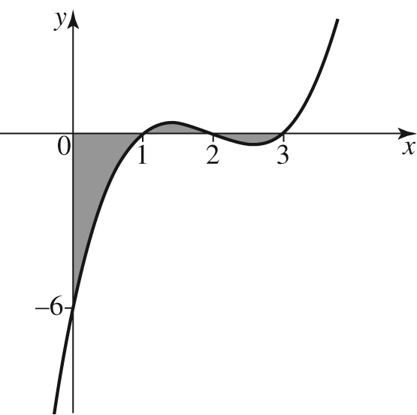
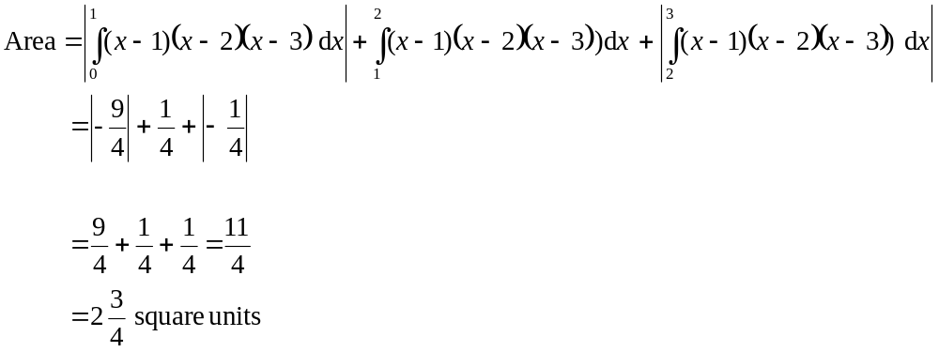
4 marks
- The velocity of a toy rocket is given by 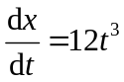. How far did the rocket travel in the first 5 seconds?
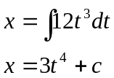
distance travelled =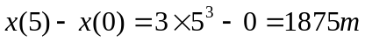

2 marks
- If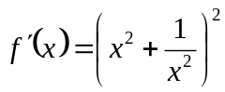and f (2) = 8, find f(x).
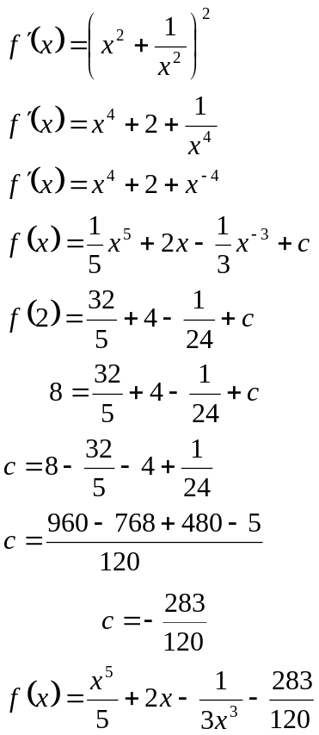

5 marks

- Find the area bounded by the curves 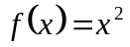 and 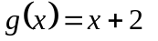

Intersection points are 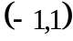and 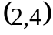
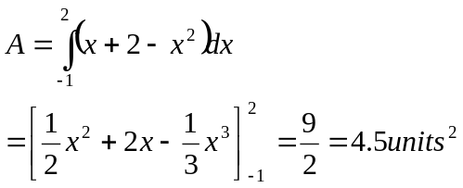

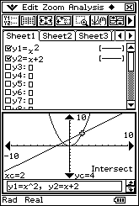

4 marks

